Supplementary Table 1. The result of univariate Cox regression analysis.
Gene | Coefficient | se | z | P | HR | HRse | HRz | HRp | HRCILL | HRCIUL
ATG4D | -0.251 | 0.115 | -2.179 | 0.029 | 0.778 | 0.09 | -2.477 | 0.013 | 0.621 | 0.975
CXCR4 | 0.175 | 0.066 | 2.63 | 0.009 | 1.191 | 0.079 | 2.414 | 0.016 | 1.045 | 1.356
DLC1 | 0.18 | 0.074 | 2.442 | 0.015 | 1.198 | 0.089 | 2.235 | 0.025 | 1.036 | 1.385
GABARAPL2 | 0.327 | 0.157 | 2.085 | 0.037 | 1.386 | 0.217 | 1.779 | 0.075 | 1.02 | 1.884
GRID1 | 0.1 | 0.049 | 2.027 | 0.043 | 1.105 | 0.054 | 1.929 | 0.054 | 1.003 | 1.217
HSPB8 | 0.099 | 0.041 | 2.429 | 0.015 | 1.104 | 0.045 | 2.313 | 0.021 | 1.019 | 1.196
MAP1LC3C | 0.118 | 0.054 | 2.199 | 0.028 | 1.125 | 0.06 | 2.074 | 0.038 | 1.013 | 1.25
NRG3 | 0.114 | 0.039 | 2.942 | 0.003 | 1.12 | 0.043 | 2.781 | 0.005 | 1.039 | 1.208

Supplementary Table 2. Autophagy-related DEGs in GC.
gene | logFC | AveExpr | t | P. Value | adj.P. Val | B | change
ATG4D | -0.403627597 | 9.24562758 | -3.257523039 | 0.001217364 | 0.003101379 | -2.268993688 | NOT
CXCR4 | 1.199149379 | 10.84184504 | 3.185712908 | 0.001554324 | 0.00391324 | -2.604269542 | UP
DLC1 | -0.617126865 | 10.22515526 | -3.26462877 | 0.001187995 | 0.003063024 | -2.40728084 | NOT
GABARAPL2 | -0.303163031 | 10.59203801 | -3.543080982 | 0.000440949 | 0.00136758 | -1.497932325 | NOT
GRID1 | -0.585100721 | 5.969511803 | -2.273355827 | 0.023520953 | 0.041945699 | -4.339989527 | NOT
HSPB8 | -3.06529641 | 9.094212662 | -11.25072908 | 8.90E-26 | 9.53E-24 | 47.48141731 | DOWN
MAP1LC3C | -0.785727568 | 2.342980826 | -3.484473737 | 0.000546235 | 0.001646399 | -0.717699439 | NOT
NRG3 | -1.454980163 | 2.67113622 | -4.951059615 | 1.08E-06 | 5.78E-06 | 5.066932044 | DOWN

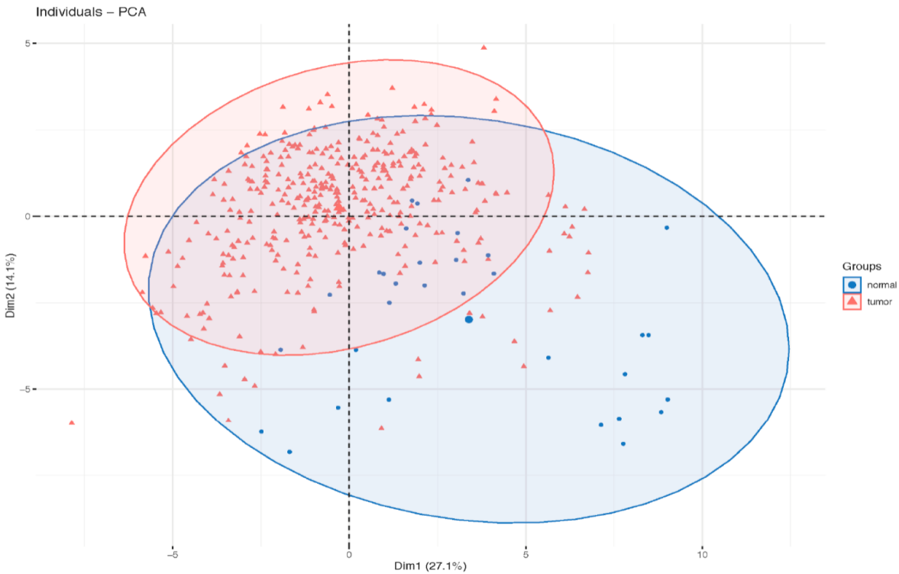
Supplementary Fig. 1. Principal components analysis performed based on differences in autophagy-related genes between normal and GC samples.

Supplementary Fig. 2. The correlation between 8 differentially expressed autophagy-related genes and CD274.

Supplementary Fig. 3. The mRNA expression of CXCR4 in the GC cells. *** p < 0.001.

